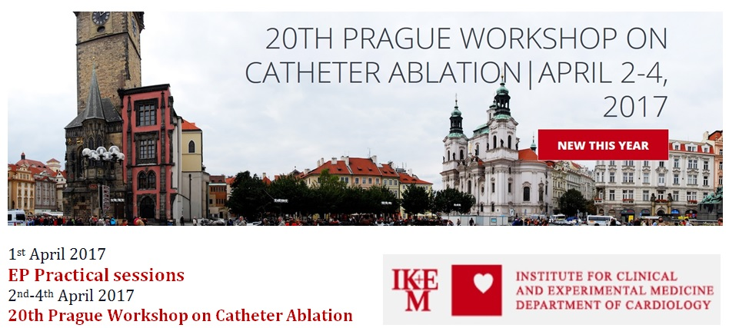

REGISTRATION FORM

NAME:

SURNAME:

DEGREE:

HOSPITAL, INSTITUTION, COMPANY:

EP EXPERIENCE (YEARS):

DEPARTMENT:

ADDRESS:

ZIP:

CITY:

COUNTRY:

PHONE NUMBER:

E-MAIL:

FOR REGISTRATION, PLEASE CONTACT:

JULIA WASZCZYKOWSKA

Foundation for Cardiological Education in Central and Eastern Europe CARDICA

Pl.Wolnosci 10/11 apt.11, 91-415 Lodz, PL

E-mail: cardica@cardica.pl

Phone number: +48 607 55 33 77

